E-Commerce Sales Data Analysis Using Power Bi

Objective
The objective of this project was to analyze raw e-commerce transaction data to extract meaningful insights related to sales performance, customer behavior, and operational efficiency.
Dataset Overview
The dataset consisted of transactional e-commerce data with the following fields
- Customer Id
- Order Id
- Order Date
- Product
- Category
- Quantity
- Price
- Payment Method
- Status
- Total
The dataset contained inconsistencies, missing values and formatting issues, making it suitable for real-world data cleaning and analysis.
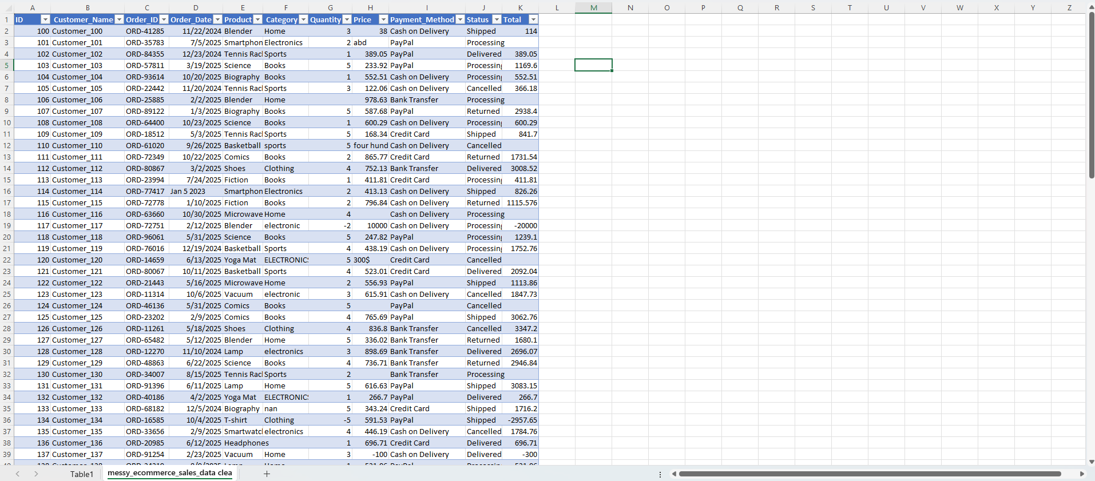

Data Cleaning (Power Query Editor)
The raw dataset was cleaned and transformed using Power Query Editor.
- Converted data types (dates, numeric fields)
- Standardized categorical values (Category, Payment Method)
- Replaced inconsistent entries using “Replace Values”
- Handling missing values using fill down and fill up techniques
- Removed or filtered invalid/irrelevant records
The transformation steps were recorded in Power Query , ensuring a repeatable and automated cleaning process.
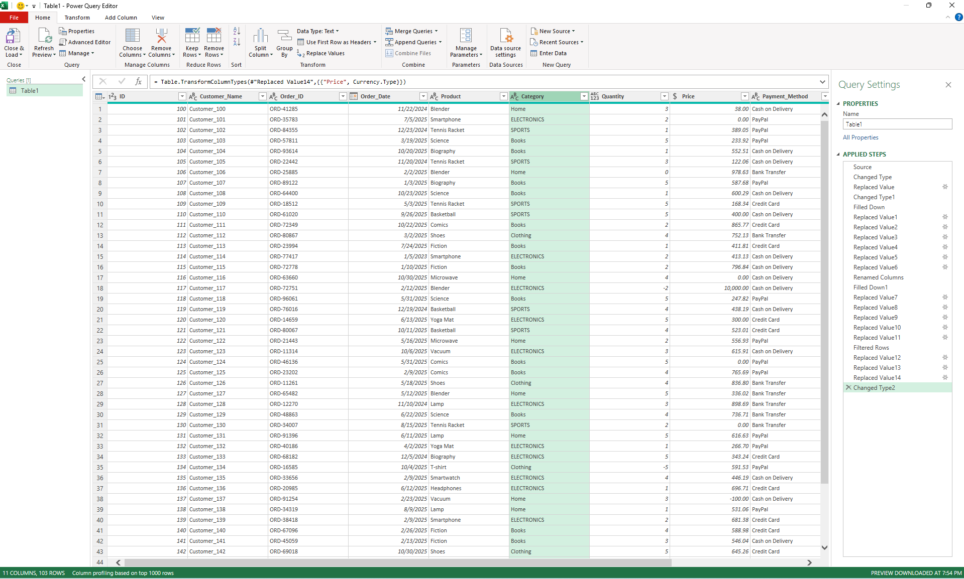
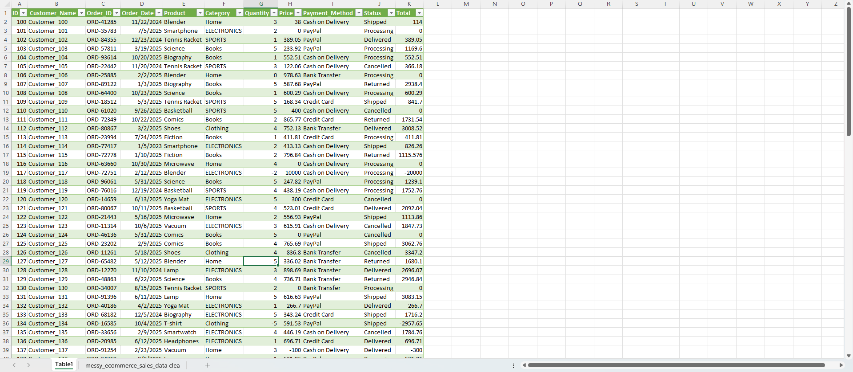
Data Transformation (Power Bi DAX )
After loading cleaned data into Power Bi:
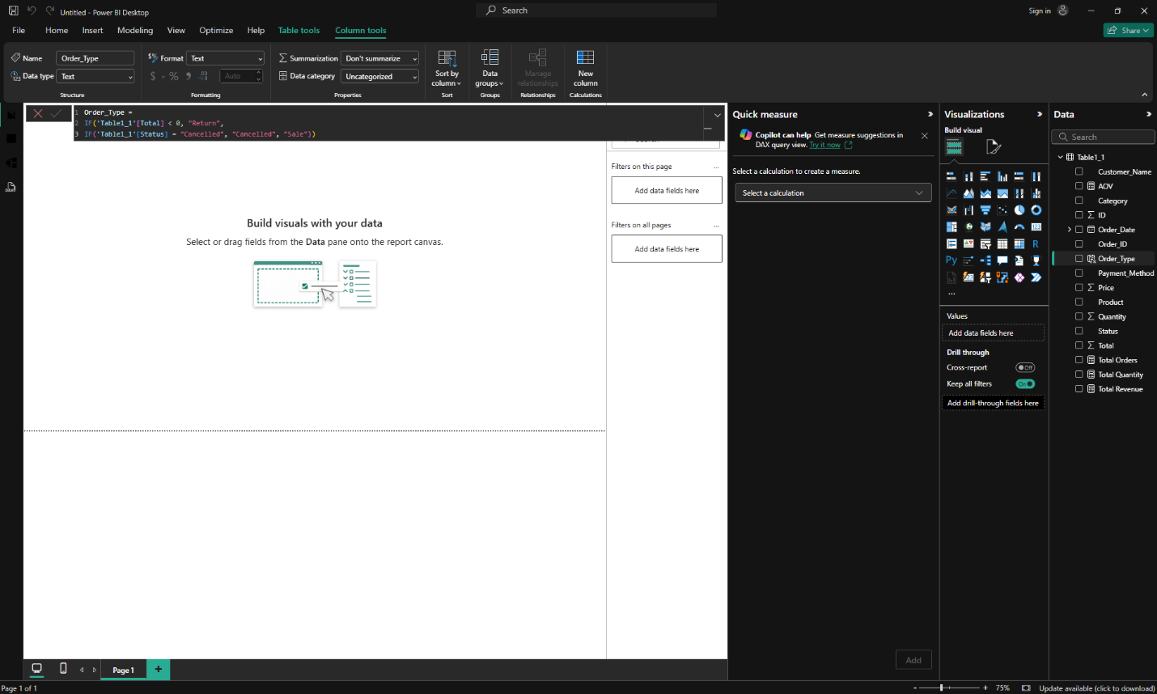
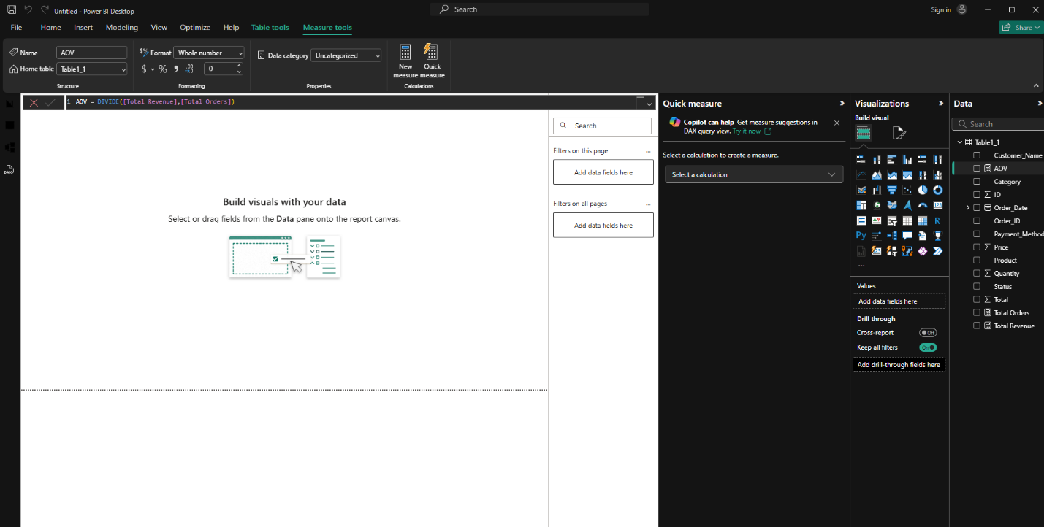

Measures Created in Power Bi:
- Total Revenue = SUM(Total)
- Total Orders = COUNT(Order ID)
- Total Quantity = SUM(Quantity)
- Average Order Value (AOV) = Revenue / Orders
Calculated Column:
- Order_Type:
- Return (negative values)
- Cancelled
- Sale
This helped in analyzing operational performance like returns and cancellations.

Dashboard Development (Power Bi)
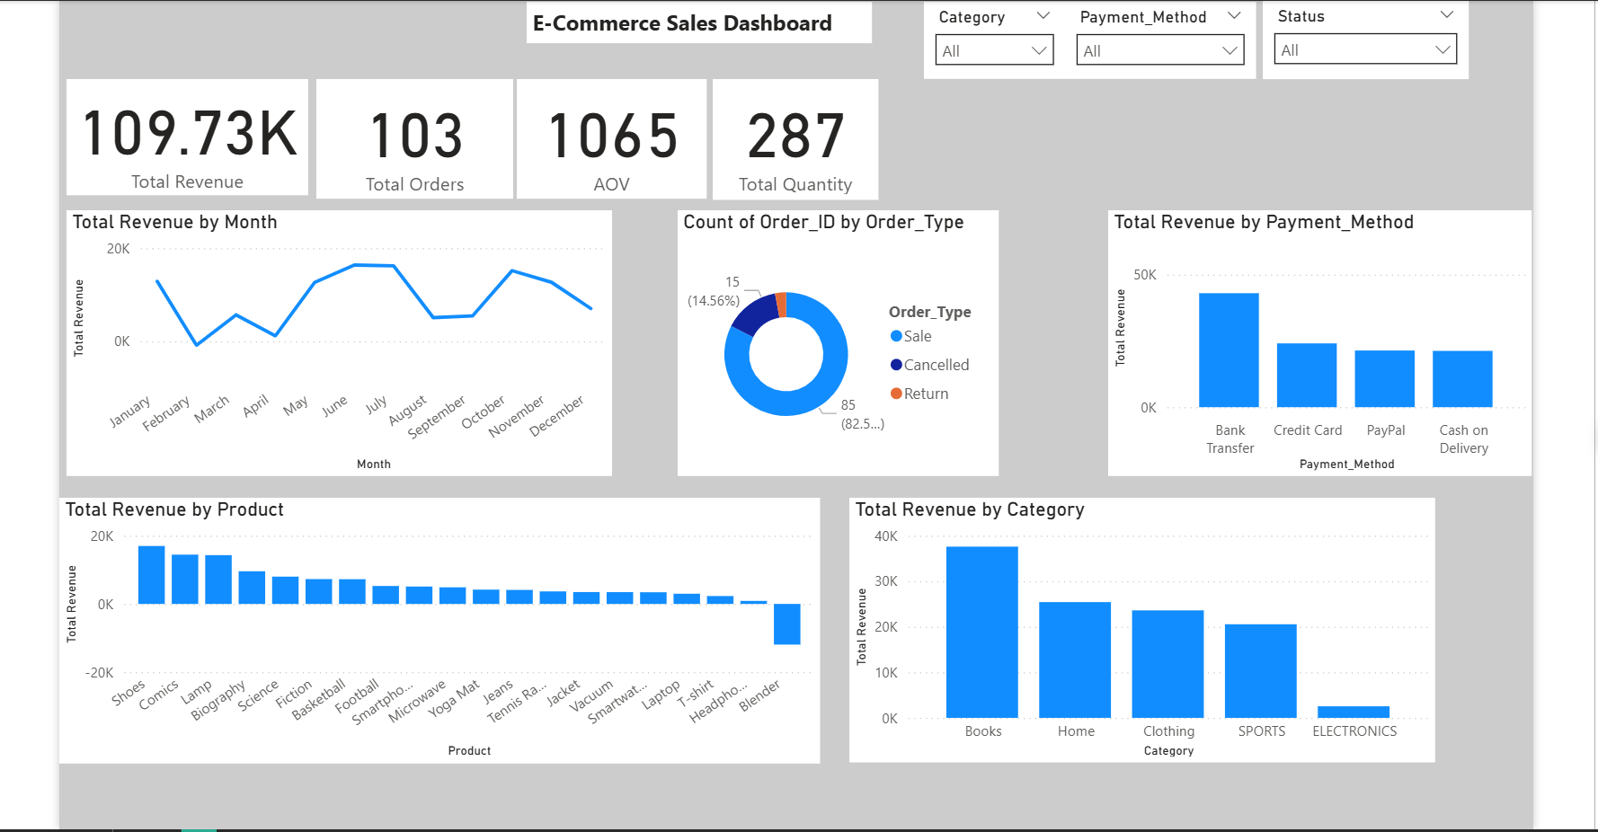
An interactive Dashboard was built with:
KPI cards:
- Total Revenue
- Total Orders
- Average Order Value
- Total Quantity Sold
Visualizations:
- Sales Trend over time (Line chart)
- Product Performance (Bar chart)
- Category-wise Revenue (Bar chart)
- Order Status Distribution (Pie chart)
- Payment Method Analysis
- Customer-wise Revenue
Filters Slicers:
- Category
- Payment Method
- Status
- Order Date
These allow dynamic filtering and deeper exploration of data.
Key Findings:
- Sales Trend Analysis
Revenue shows fluctuations across months, with noticeable peaks around mid-year and later months, indicating seasonal demand patterns
- Order Type Distribution
Approx 82.5% or orders are successful sales, while the remaining consist of cancellations and returns, which still impact overall revenue.
- Payment Method
Bank Transfer contributes the highest revenue, followed by Credit card and PayPal, indicating customer preference toward digital payment methods.
- Category Performance
Books is the top-performing category, generating the highest revenue, while Electronics contributes the least.
- Product Performance
Products like Shoes, Comics, and Lamps are among the top revenue generators, whereas some products (e.g. Blender) show negative revenue due to returns.

Business Insights:
- High revenue concentration in Books suggests an opportunity to expand offerings or marketing in this category.
- Negative revenue from certain products highlights the impact of returns, indicating potential quality or expectation issues.
- Strong reliance on Bank Transfer suggests optimizing and promoting this payment method further.
- Seasonal peaks indicate opportunities for targeted promotions and inventory planning.
- Reducing cancellations and returns can significantly improve overall profitability.

Final Conclusions:
The analysis highlights key revenue drivers, including product categories, customer purchasing patterns, and payment preferences. While the majority of transactions are successful, returns and cancellations negatively affect overall performance. Leveraging high-performing categories and reducing operational inefficiencies can improve business outcomes.

